**Stream Cipher: RC4**

RC4, which stands for Rivest Cipher 4, is a symmetric stream cipher designed by Ron Rivest in 1987. It gained popularity due to its simplicity, efficiency, and speed. The algorithm is widely used in various security protocols, including WEP (Wired Equivalent Privacy) for wireless communication and SSL/TLS for securing web connections. It is a symmetric key encryption algorithm that encrypts plain text in small chunks producing multiple stream ciphers. It encrypts the system's data and ensures the secure delivery of confidential data over the websites.

### **THEORETICAL FOUNDATIONS:**

**Key Schedule:**

* RC4 uses a variable-length key to initialise a permutation of all 8-bit possible values (256 elements) in the S-box (state box). The S-box is essentially an array, and its initial state is determined by the key.
* The key is used to generate a pseudorandom permutation of the S-box through the Key Scheduling Algorithm (KSA). The KSA involves swapping elements of the S-box based on the key.

**Pseudorandom Generation Algorithm (PRGA):**

* The PRGA produces a stream of pseudorandom bytes that are XORed with the plaintext or ciphertext to generate the encrypted or decrypted message.
* It uses two indices, i and j, to iteratively swap elements in the S-box, creating a dynamic and unpredictable keystream.
* The keystream is generated by selecting elements from the S-box based on the values of i and j and XORing them.

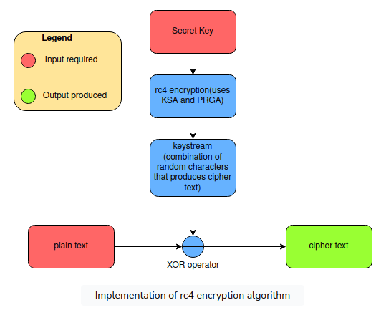

**WORKING PRINCIPLES:**

**Key Initialization**:

* RC4 takes a variable-length key (typically between 40 and 2048 bits) as input.
* The key is then used to initialise the S-box using the KSA.

**Pseudorandom Keystream Generation:**

* The keystream is generated by using the PRGA, which iteratively updates the S-box by swapping elements.
* The PRGA uses two pointers, i and j, which are incremented in a complex manner to select S-box elements for XORing with the plaintext or ciphertext.
* The keystream generated by the PRGA is effectively a pseudorandom permutation of the possible 8-bit values.

**Encryption/Decryption**:

* During encryption, the plaintext is XORed with the keystream to produce the ciphertext.
* During decryption, the same keystream is XORed with the ciphertext to recover the original plaintext.
* The XOR operation is crucial, as it provides a reversible transformation and ensures that encryption and decryption are symmetric processes.

**Security Considerations**:

* RC4 has faced vulnerabilities, such as biases in its initial keystream output, which can lead to security compromises.
* Due to these vulnerabilities, RC4 is generally not recommended for use in new systems, and more secure alternatives like AES are preferred.

**REAL-WORLD APPLICATION**

**Wireless Security (WEP):**

* RC4 was initially used in the WEP protocol to secure wireless communication. However, WEP suffered from serious vulnerabilities due to the inadequate implementation of RC4, leading to its deprecation.

**SSL/TLS:**

* RC4 was widely used in the early implementations of SSL and TLS protocols to provide secure communication over the internet. However, vulnerabilities, including biases in the keystream, led to its deprecation in favour of more secure algorithms like AES.

**Remote Desktop Protocols:**

* Some remote desktop protocols, such as RDP (Remote Desktop Protocol), have employed RC4 for encryption. However, its usage in this context has decreased as security concerns have risen.

**MATHEMATICAL ANALYSIS**

**Key Length Analysis:**

* Evaluate the impact of different key lengths on the security of RC4.
* Analyse the key space to ensure it provides a sufficient level of entropy, making brute-force attacks computationally infeasible.

**Key Scheduling Algorithm (KSA):**

* Verify the randomness and uniform distribution of the initial permutation generated by the KSA.
* Analyse the sensitivity of the S-box to changes in the key.

**Pseudorandom Generation Algorithm (PRGA):**

* Assess the statistical properties of the keystream produced by the PRGA.
* Investigate the periodicity of the keystream and ensure it behaves like a truly random sequence.

**Entropy of the Keystream:**

* Calculate the entropy of the keystream to measure the randomness and unpredictability.

**SECURITY ANALYSIS:**

**Biases in the Keystream:**

* Conduct statistical tests to identify biases in the initial output of the keystream.
* Investigate whether certain bytes or bits in the keystream exhibit non-random behaviour.

**Key Scheduling Weaknesses:**

* Explore the impact of different keys on the S-box permutation.
* Analyse the sensitivity of the key scheduling algorithm to variations in the key.

**Cryptanalysis Techniques:**

* Apply known cryptanalysis techniques, such as linear and differential cryptanalysis, to identify weaknesses in RC4.
* Analyse the resistance of RC4 against algebraic attacks and other mathematical approaches.

**Practical Exploits:**

* Implement practical exploits, including known attacks like the Fluhrer-McGrew attack, to demonstrate vulnerabilities.
* Assess the success rate and feasibility of exploiting identified weaknesses.

**Comparison with Modern Ciphers:**

* Compare the security features of RC4 with modern symmetric ciphers, such as AES.
* Consider the advancements in cryptanalysis and computing power to evaluate RC4's resilience against contemporary threats.

**Side-Channel Analysis:**

* Investigate potential side-channel vulnerabilities, including timing attacks or power analysis attacks.
* Assess the robustness of RC4 against these types of attacks.

**Quantum Threats:**

* Consider the algorithm's vulnerability to quantum attacks, especially in the context of evolving quantum computing capabilities.
* Simulation and Testing:Implement the algorithm in different scenarios, varying parameters such as key length and plaintext characteristics.
* Run simulations and conduct testing to observe the behaviour of RC4 under different conditions.

**Peer Review:**

* Subject the algorithm to peer review within the cryptographic community.
* Encourage experts to analyse the algorithm and provide feedback on its strengths and weaknesses.